ABSTRACT
In today's digital era, managing student attendance manually through registers, roll calls, or traditional attendance sheets creates several problems such as time consumption, human errors, inaccurate records, and the possibility of proxy attendance. The AI-Based Attendance System Using Face Recognition is developed to overcome these limitations by providing an intelligent, automated, and contactless platform for identifying students and recording their attendance.
The system is designed for educational institutions such as schools, colleges, universities, and training institutes that require an efficient and reliable method for attendance management. Students are registered in the system along with their facial information, and during an active attendance session, the system captures and detects faces through a camera. The AI-based face recognition module compares the detected face with registered facial data and automatically marks the attendance after successful identity verification.
On the other side, the Admin and Faculty can manage student information, facial registration, attendance sessions, and attendance records through the system. The application provides features such as attendance monitoring, dashboard statistics, search and filtering, report generation, and data export. Additional verification mechanisms such as multi-frame confirmation, anti-spoofing, and liveness detection can also be used to improve the security and reliability of the attendance process.
The project is developed using Python and FastAPI for backend services, along with modern web technologies for the user interface. Artificial Intelligence, Computer Vision, and face recognition technologies are used to detect and identify students, while a database is used to securely store student details, facial data, attendance sessions, and attendance records.
Overall, this project aims to replace the traditional manual attendance process with a modern, intelligent, secure, and cost-effective automated system. By using Artificial Intelligence and Face Recognition, the system saves time, reduces manual effort and human errors, minimizes proxy attendance, and improves the accuracy and efficiency of attendance management for both educational institutions and students.

INTRODUCTION TO PROJECT SYSTEM

1.1 Introduction
In today's digital era, educational institutions are increasingly adopting advanced technologies to automate traditional processes and improve efficiency. Attendance management is an important academic activity, but conventional methods such as manual roll calls, signatures, and ID card-based systems are time-consuming and may lead to human errors and proxy attendance. Therefore, there is a growing need for a smart, automated, and reliable attendance management system.
AttendAI is an AI-based smart attendance system that uses Face Recognition and Computer Vision to automatically identify students and mark their attendance. The system captures facial information through a camera, detects the student's face, and compares it with the registered facial data stored in the system. Once a student's identity is successfully verified, the attendance is recorded automatically, reducing the need for manual intervention.
The proposed system uses modern technologies such as Artificial Intelligence, Deep Learning, FastAPI, and Face Recognition algorithms to provide an efficient attendance solution. To improve the reliability and security of the system, it can also include mechanisms such as liveness detection, anti-spoofing, and multi-frame face verification, which help reduce the possibility of fake or proxy attendance using photographs or digital screens.
Overall, AttendAI aims to provide a contactless, secure, accurate, and automated attendance management solution for educational institutions. The system helps teachers save time, improves the accuracy of attendance records, reduces administrative workload, and provides better monitoring through attendance reports and dashboard features. By integrating AI with modern web technologies, the project represents a step towards the digital transformation of traditional attendance systems.

1.2 Problem Statement

Traditional attendance management systems used in educational institutions are often manual, time-consuming, and inefficient. Methods such as calling students by name, signing attendance sheets, or using ID cards require significant effort from teachers and consume valuable classroom time. These traditional approaches may also result in human errors, incorrect records, and difficulties in maintaining and managing attendance data for a large number of students.

Another major problem is proxy attendance, where one student may attempt to mark attendance on behalf of another student. Basic systems based on ID cards, passwords, or manual signatures cannot always verify whether the actual student is physically present. This affects the accuracy and reliability of attendance records and makes it difficult for institutions to maintain a transparent attendance process.

Existing biometric attendance systems may provide better identification but often require physical contact, dedicated hardware, and regular maintenance. They can also create delays when a large number of students need to mark attendance. Therefore, there is a need for a contactless, automated, and intelligent solution that can identify students accurately while reducing manual work and minimizing the chances of fraudulent attendance.

The problem addressed by the proposed AttendAI system is to develop an AI-based attendance management solution using Face Recognition and Computer Vision. The system aims to automatically detect and recognize registered students, verify their presence, and record attendance digitally. By incorporating features such as facial verification, multi-frame confirmation, anti-spoofing mechanisms, attendance reports, and dashboard monitoring, the proposed system seeks to improve the accuracy, security, efficiency, and reliability of the overall attendance management process.

1.3 Objectives

The main objective of the proposed AttendAI – AI-Based Smart Attendance Management System using Face Recognition is to develop an intelligent, automated, and secure system for managing student attendance. The system is designed to replace traditional manual attendance methods with an AI-based solution that can automatically identify students and record their attendance efficiently.

The specific objectives of the project are as follows:

To develop an automated attendance management system using Artificial Intelligence and Face Recognition technology.

To detect and recognize registered students through facial identification and automatically mark their attendance.

To reduce the time and manual effort required for traditional attendance processes such as roll calls and manual registers.

To minimize the possibility of proxy or fraudulent attendance by verifying the identity of students through facial recognition and anti-spoofing mechanisms.

To maintain attendance records digitally in a centralized database for secure and efficient data management.

To provide an easy-to-use interface for managing student registration, attendance sessions, and facial data.

To generate attendance reports and allow users to monitor attendance records through dashboards and analytical features.

To improve the overall accuracy, efficiency, security, and reliability of attendance management in educational institutions.

Overall, the project aims to provide a contactless, intelligent, and modern attendance solution that supports the digital transformation of educational institutions and reduces the limitations associated with traditional attendance systems.

1.4 Scope of the Project
The scope of the proposed AttendAI – AI-Based Smart Attendance Management System using Face Recognition is focused on automating and improving the attendance process in educational institutions. The system is designed to replace traditional manual attendance methods with an intelligent and contactless solution that uses Artificial Intelligence, Computer Vision, and Face Recognition technology to identify students and record their attendance digitally.
The system allows administrators or authorized users to register students and store their basic information along with facial data. During an attendance session, the system detects faces through a camera or video input and compares them with the registered facial data. Once a student's identity is successfully verified, the system automatically records the attendance, helping to reduce manual work, save classroom time, and improve the accuracy of attendance records.
The project also includes features for managing attendance sessions, student information, faculty and department-related data, attendance records, dashboards, and reports. Authorized users can view attendance information, monitor attendance statistics, and generate or export attendance reports. Security and reliability can be improved through mechanisms such as multi-frame verification, anti-spoofing, and liveness detection to reduce the possibility of proxy or fake attendance.
The future scope of the project can be extended by integrating the system with college ERP systems, mobile applications, cloud platforms, real-time notifications, GPS or location-based verification, and advanced AI models. Therefore, AttendAI has the potential to be developed into a scalable and comprehensive smart attendance solution that can be used in schools, colleges, universities, training institutes, and other organizations where automated attendance management is required.

FEASIBILITY STUDY
The feasibility study evaluates whether the proposed AI-Based Attendance System Using Face Recognition can be successfully developed and implemented. It examines the project from technical, economic, operational, security, and schedule perspectives.
- Technical Feasibility: The system uses modern and widely available technologies such as Python, FastAPI, HTML, CSS, JavaScript, OpenCV, DeepFace, FaceNet, and a database system. These technologies are suitable for developing an AI-based face recognition attendance system. A webcam or camera can be used to capture facial images, while the AI model processes and verifies the identity of registered students.
- Economic Feasibility: The project uses mostly open-source technologies and software tools, which helps reduce the overall development cost. Python, FastAPI, OpenCV, Visual Studio Code, and other required development libraries can be used without significant licensing costs. Therefore, the system is economically feasible for educational institutions and academic projects.
- Operational Feasibility: The proposed system provides an automated and user-friendly attendance process. Admins can manage students and system information, Faculty members can conduct attendance sessions, and Students can have their attendance marked automatically through face recognition. This reduces manual effort and saves valuable classroom time.
- Security Feasibility: The system includes authentication and authorization mechanisms to provide controlled access to Admin and Faculty users. Face verification, multi-frame confirmation, and anti-spoofing or liveness detection mechanisms can improve security and help reduce proxy attendance or attempts to use photographs for false attendance marking.
- Schedule Feasibility: The project can be developed within the given academic semester timeline by dividing the work into different phases, including requirement analysis, system design, frontend development, backend development, face recognition integration, database implementation, testing, and documentation.
REQUIREMENT GATHERING
The requirements for the proposed AI-Based Attendance System Using Face Recognition were collected through the observation of traditional manual attendance processes, research on existing biometric and face recognition attendance systems, analysis of educational institution requirements, and discussions among the project team.
The main purpose of requirement gathering was to identify the problems associated with manual attendance, such as time consumption, human errors, paperwork, and proxy attendance. Based on these requirements, the system was designed with three main users: Admin, Faculty, and Student.
Main Users
Admin
- Login securely to the system
- Manage student information
- Manage faculty information
- Register and manage facial data
- View and manage attendance records
- Monitor attendance through the dashboard
- Generate and export attendance reports
- Manage courses and other system information
Faculty
- Login securely to the system
- Start and manage attendance sessions
- Access the camera for attendance processing
- Use face recognition to identify students
- Monitor automatic attendance marking
- View student attendance records
- Search and filter attendance information
- View attendance reports
Student
- Register personal and academic information
- Provide facial data for face registration
- Participate in attendance sessions
- Get identified through face recognition
- Have attendance marked automatically
- View personal attendance records and history, where access is available
- Receive attendance-related notifications
REQUIREMENT ANALYSIS
The requirement analysis identifies and defines the functional and non-functional requirements of the proposed AI-Based Attendance System Using Face Recognition.
Functional Requirements
- Secure authentication and login for authorized users.
- Role-based access for Admin, Faculty, and Student.
- Student registration and management.
- Faculty and course management.
- Capture and store facial data of registered students.
- Detect faces using camera or video input.
- Recognize registered students using AI-based face recognition.
- Automatically mark attendance after successful identity verification.
- Create and manage attendance sessions.
- Prevent duplicate attendance marking during the same session.
- Apply verification mechanisms such as multi-frame confirmation.
- Support anti-spoofing and liveness detection where applicable.
- View, search, and filter attendance records.
- Generate attendance reports and export data.
- Display attendance information through dashboards.
- Send or display system and attendance-related notifications.
- Manage student profiles and system information.
Non-Functional Requirements
- Performance: The system should detect and process faces efficiently and provide a fast response during attendance sessions.
- Usability: The system should provide a simple, user-friendly, and easy-to-understand interface for Admin, Faculty, and Students.
- Security: The system should provide authentication, authorization, secure password storage, input validation, and controlled access to sensitive attendance data.
- Reliability: The system should accurately maintain attendance records and minimize duplicate or incorrect attendance entries.
- Accuracy: The face recognition process should provide reliable identification of registered students under suitable camera and lighting conditions.
- Maintainability: The system should use a modular architecture so that features, AI models, and system components can be updated easily.
- Scalability: The system should support future expansion to accommodate a larger number of students, courses, departments, and attendance sessions.
EXISTING SYSTEM
The existing attendance process in many educational institutions mainly uses traditional methods such as manual roll calls, paper registers, signatures, ID cards, or conventional biometric devices. Manual attendance systems are simple to implement but require significant time and effort from faculty members. They can also result in human errors, incorrect records, and difficulties in managing large amounts of attendance data.
Traditional systems may also allow proxy attendance, where one student attempts to mark attendance on behalf of another. Some biometric systems can reduce this problem but may require dedicated hardware, physical contact, and regular maintenance. Existing third-party attendance platforms may also have limited customization and recurring subscription costs.
PROPOSED SYSTEM
The proposed AI-Based Attendance System Using Face Recognition is an intelligent and automated solution designed to modernize the traditional attendance process. The system uses Artificial Intelligence, Computer Vision, and Face Recognition technology to identify registered students and automatically record their attendance.
Administrators can manage students, faculty, courses, facial data, and overall system information. Faculty members can create and conduct attendance sessions using camera input, while the AI-based face recognition module detects and verifies student identities. After successful verification, the system automatically records attendance in the database.
The system also provides features such as attendance dashboards, search and filtering, report generation, CSV export, notifications, multi-frame confirmation, and optional anti-spoofing or liveness detection mechanisms. This helps create a secure, contactless, accurate, and efficient attendance management solution.
ADVANTAGES OF PROPOSED SYSTEM
- Reduces manual attendance work.
- Saves valuable classroom and faculty time.
- Minimizes paperwork and manual record maintenance.
- Reduces the possibility of proxy attendance.
- Provides automated attendance marking through face recognition.
- Maintains centralized and digital attendance records.
- Provides easy access to attendance information and reports.
- Supports search and filtering of attendance records.
- Improves accuracy and efficiency in attendance management.
- Provides dashboard-based monitoring and analytics.
- Supports report generation and data export.
- Can be customized according to the requirements of an educational institution.
- Provides a foundation for future integration with ERP systems, mobile applications, and cloud platforms.
LIMITATIONS
- The accuracy of face recognition can be affected by poor lighting, camera quality, face angle, or facial occlusion.
- The system requires proper facial registration of students before attendance can be recognized accurately.
- Performance may decrease when processing a very large number of students simultaneously on low-performance hardware.
- A camera or webcam is required for capturing student faces.
- Anti-spoofing and advanced liveness detection may require additional processing and further model improvements.
- Proper server infrastructure or cloud hosting is required for large-scale online deployment.
- Advanced integrations such as SMS, email, or real-time mobile notifications may not be included in the current version.

- SYSTEM REQUIREMENT SPECIFICATION

2.1 Introduction to SRS
A Software Requirement Specification (SRS) is a detailed document that describes the requirements, features, functionalities, constraints, and expected behavior of a software system. It acts as a bridge between the users, developers, and other stakeholders by clearly defining what the proposed system should do and how it should perform. An SRS document helps in understanding the project requirements before the actual development process begins.
For the proposed AttendAI – AI-Based Smart Attendance Management System using Face Recognition, the SRS defines the requirements needed to develop an automated, intelligent, and secure attendance management system. It describes the major features of the system, such as student registration, facial data management, face detection and recognition, attendance marking, attendance session management, dashboard monitoring, report generation, and data storage.
The SRS also specifies the functional requirements and non-functional requirements of the system. Functional requirements describe the operations that the system must perform, whereas non-functional requirements define quality-related aspects such as security, performance, reliability, usability, and scalability. It also identifies the hardware and software requirements necessary for the successful development and execution of the AttendAI system.
Overall, the SRS provides a clear foundation for the development of the AttendAI project. It helps developers understand the expected behavior of the system, assists in designing and testing the application, and ensures that the final system meets the requirements of educational institutions. Thus, the Software Requirement Specification plays an important role in developing a structured, reliable, and efficient AI-based attendance management system.

2.2 Hardware Requirement
For the development, testing, and demonstration of the proposed AttendAI – AI-Based Smart Attendance Management System using Face Recognition, a computer or laptop with suitable hardware configuration is required. The system should have sufficient processing power, memory, storage, and display capability to run the frontend, backend, database, and AI-based face recognition modules efficiently.
The following minimum hardware requirements are recommended:
- Processor: Intel Core i3 or equivalent processor (or higher)
- RAM: Minimum 4 GB RAM (8 GB recommended for better performance)
- Hard Disk: At least 20 GB of free storage space
- Display: Minimum screen resolution of 1366 × 768 pixels or higher
- Camera: Built-in webcam or external USB camera for capturing facial images and performing face recognition
- Internet Connection: Required for online research, downloading dependencies, and future cloud hosting or deployment
These hardware specifications are sufficient for the basic development and demonstration of the AttendAI system. However, for large-scale deployment or faster AI-based face recognition, a higher-performance processor, additional RAM, and optional GPU support may improve the overall performance of the system.

2.3 Software Requirement
The proposed AttendAI – AI-Based Smart Attendance Management System using Face Recognition requires various software tools, programming languages, frameworks, and libraries for its development, testing, and execution. The system combines modern web technologies with Artificial Intelligence, Computer Vision, and Face Recognition techniques to provide an automated attendance management solution.
The software tools and technologies used in this project are as follows:
- Operating System: Windows 10 / Windows 11 or any modern operating system
- Programming Language: Python
- Backend Framework: FastAPI
- Frontend Technologies: HTML, CSS, JavaScript
- Database: SQLite / configured database system for storing student and attendance records
- AI and Face Recognition: DeepFace and FaceNet-based facial recognition technology
- Computer Vision: OpenCV and related image-processing libraries
- Server: Uvicorn ASGI Server
- API Development and Testing: FastAPI interactive API documentation / Postman
- Code Editor: Visual Studio Code
- Package Manager: Python pip
- Browser: Google Chrome / Mozilla Firefox / Microsoft Edge
The Python programming language is used for implementing the backend logic and Artificial Intelligence modules of the system. FastAPI is used to develop high-performance APIs and manage communication between the frontend, backend, and database. Computer Vision and face recognition libraries are used for face detection, facial feature extraction, and identity verification.
The system can be executed locally using the Uvicorn server, while Visual Studio Code can be used as the primary development environment. Modern web browsers are required to access and test the web interface. These software requirements provide the necessary environment for developing, testing, and demonstrating the AttendAI system effectively.

2.4 System Users
The proposed AttendAI – AI-Based Smart Attendance Management System using Face Recognition mainly consists of the following types of users:
1. Admin
The Admin is the main administrator of the system and has overall control over the application. The Admin is responsible for managing student information, departments, faculty details, facial registration data, attendance records, and system-related activities. The Admin can also monitor attendance through the dashboard, manage attendance sessions, generate reports, and maintain the database records. The Admin ensures that the system operates properly and that attendance data is managed securely.
2. Faculty / Authorized User
The Faculty or Authorized User uses the system to conduct and manage attendance sessions. The user can start an attendance session and use the face recognition system to identify registered students and mark their attendance automatically. The Faculty can also view attendance records, monitor student attendance, and access relevant attendance reports.
3. Student
The Student is the individual whose attendance is recorded by the system. Students are registered in the system with their basic details and facial information. During an active attendance session, the system detects and recognizes the student's face and automatically records their attendance after successful verification. Students may also view their attendance information where student access is provided.
Thus, the AttendAI system provides different levels of access and functionality to ensure efficient management of students, attendance sessions, facial recognition data, and attendance records.

2.5 Description of User Role
The AttendAI system provides different roles and responsibilities to ensure the proper management of students, attendance sessions, and attendance records. The main user roles of the system are described below.
Admin Role:
- Secure access to the system and overall system management.
- Add, update, delete, and manage student information.
- Register and manage facial data required for face recognition.
- Manage departments, faculty information, and other academic details.
- Create, monitor, and manage attendance sessions.
- View attendance records and dashboard statistics.
- Search and filter student and attendance information.
- Generate attendance reports and export attendance data in CSV format.
- Manage and maintain database records and overall system activities.
Faculty / Authorized User Role:
- Securely access the attendance management system.
- Start and manage attendance sessions for students.
- Use the face recognition system to automatically identify students.
- Monitor the attendance marking process in real time.
- View and search attendance records for relevant students or sessions.
- Access attendance reports and monitor student attendance information.
- Manage attendance-related activities assigned by the administrator.
Student Role:
- Register basic information and facial details in the system.
- Participate in attendance sessions through facial recognition.
- Have attendance automatically recorded after successful face verification.
- View personal attendance records and attendance history, where student access is available.
- Benefit from a fast, contactless, and automated attendance process.
The role-based structure of the AttendAI system helps maintain proper access control and ensures that different users can perform only their authorized activities. This improves the overall security, efficiency, and reliability of the attendance management process.

2.6 System Modules
The proposed AttendAI – AI-Based Smart Attendance Management System using Face Recognition is divided into several main modules. Each module performs specific functions and works together to provide an efficient, secure, and automated attendance management process.
1. Authentication Module
2. Student Registration and Face Management Module
3. Face Recognition and Verification Module
4. Attendance Session Management Module
5. Attendance Management Module
6. Dashboard and Analytics Module
7. Report Generation and Export Module
8. Database Management Module
9. Anti-Spoofing and Security Module

2.7 Description of Modules
The proposed AttendAI – AI-Based Smart Attendance Management System using Face Recognition is divided into several main modules. Each module performs specific functions and works together to provide an efficient, secure, and automated attendance management process.
1. Authentication Module
This module is responsible for secure access to the system. It manages user authentication and authorization for administrators and other authorized users. The module helps ensure that only authorized users can access and manage system functions and attendance-related information.
2. Student Registration and Face Management Module
This module is used to register students in the system and manage their personal information. It also captures and stores facial data required for the face recognition process. The registered facial information is used by the AI system to identify students during attendance sessions.
3. Face Recognition and Verification Module
This is the core module of the AttendAI system. It uses Artificial Intelligence and Computer Vision techniques to detect and recognize student faces. The captured face is compared with registered facial data to identify the student. Multi-frame verification and other security mechanisms can be used to improve recognition accuracy and reliability.
4. Attendance Session Management Module
This module allows authorized users or faculty members to create, start, manage, and close attendance sessions. During an active session, the system recognizes registered students and automatically records their attendance after successful verification.
5. Attendance Management Module
This module manages all attendance records generated by the system. Authorized users can view, search, filter, and manage attendance information based on students, dates, sessions, departments, or other available criteria.
6. Dashboard and Analytics Module
The dashboard provides an overview of important system and attendance information. Administrators and authorized users can monitor attendance statistics, student records, active sessions, and other relevant information through a centralized interface.
7. Report Generation and Export Module
This module is used to generate attendance reports and summaries. Authorized users can review attendance information and export records in formats such as CSV, making it easier to maintain documentation and perform further analysis.
8. Database Management Module
This module is responsible for storing and managing student details, facial data, attendance records, sessions, and other system information. It ensures that the data is organized and available for retrieval whenever required.
9. Anti-Spoofing and Security Module
This module improves the security and reliability of the face recognition process. It helps reduce the possibility of fake or proxy attendance by using verification mechanisms such as anti-spoofing, liveness detection, and multi-frame confirmation.
Overall, these modules work together to provide a secure, automated, intelligent, and efficient attendance management system using Artificial Intelligence and Face Recognition technology.

2.8 Timeline Chart
The development of the AttendAI – AI-Based Smart Attendance Management System using Face Recognition was divided into different phases. The project timeline includes requirement analysis, system design, frontend and backend development, AI face recognition integration, database implementation, testing, and final documentation.
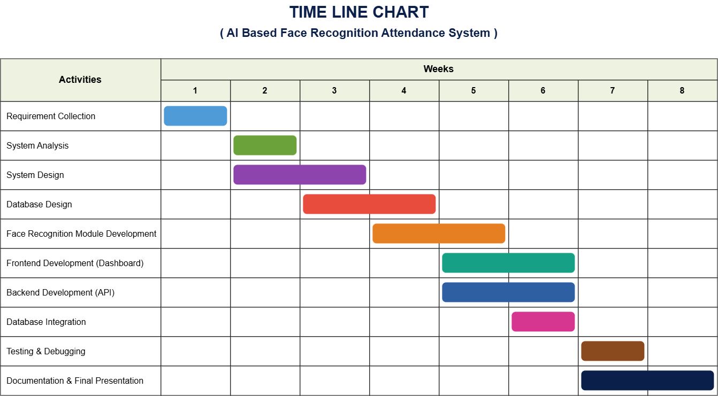
The above timeline represents the planned development process of the AttendAI project. The initial phase focuses on understanding the project requirements and designing the overall system architecture. The middle phases involve the development of the frontend, backend, database, and AI-based face recognition modules. The final phases focus on testing, debugging, report generation, documentation, and deployment of the system.

3. SYSTEM FLOW DIAGRAM
The System Flow Diagram shows the overall working process of the AttendAI – AI-Based Smart Attendance Management System using Face Recognition. It represents how the system processes information from student registration and authentication to face detection, facial recognition, identity verification, and automatic attendance marking.
The working process begins with the registration of students and the storage of their basic information and facial data in the system database. When an authorized user starts an attendance session, the system captures video frames through a camera and detects the faces of students. The detected facial features are processed by the AI-based face recognition module and compared with the facial data of registered students.
After successful recognition and verification, the system checks additional validation conditions such as multi-frame confirmation and available anti-spoofing or liveness detection mechanisms. If the identity is successfully verified, the attendance of the recognized student is automatically recorded in the database. The system then updates the attendance dashboard and makes the records available for monitoring and report generation.
The diagram clearly represents the interaction between the main system components, including the Admin/Faculty, Student Registration Module, Camera Input, Face Recognition Engine, Verification Module, Attendance Management Module, Dashboard, Reports, and Database. All these components interact with the central system database to ensure that student and attendance information remains accurate, secure, and up to date.

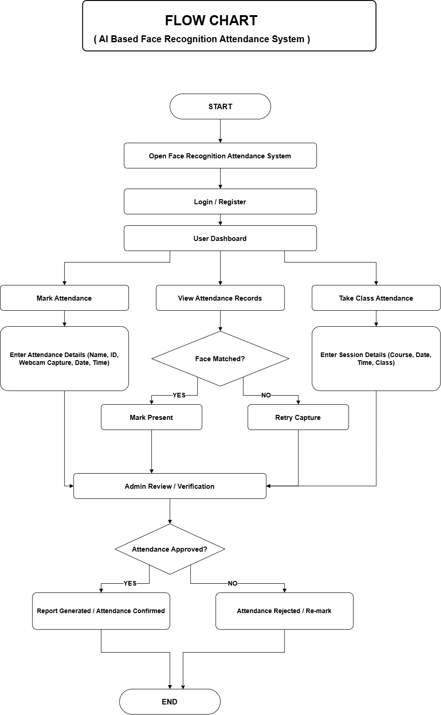
4. USE CASE DIAGRAM
Use Case Diagrams show the interaction between the main actors and different functionalities of the AttendAI – AI-Based Smart Attendance Management System using Face Recognition. The system has three main actors: Admin, Faculty, and Student. Each actor interacts with the system according to their assigned roles and permissions.
4.1 Use Case Diagram – Admin
The Admin is responsible for managing and controlling the overall system. The main use cases of the Admin are:
- Login to the system
- Manage student information
- Register and manage facial data
- Manage faculty information
- Manage departments
- View and manage attendance records
- Monitor dashboard and statistics
- Generate attendance reports
- Export attendance data
- Manage system records
- Logout from the system
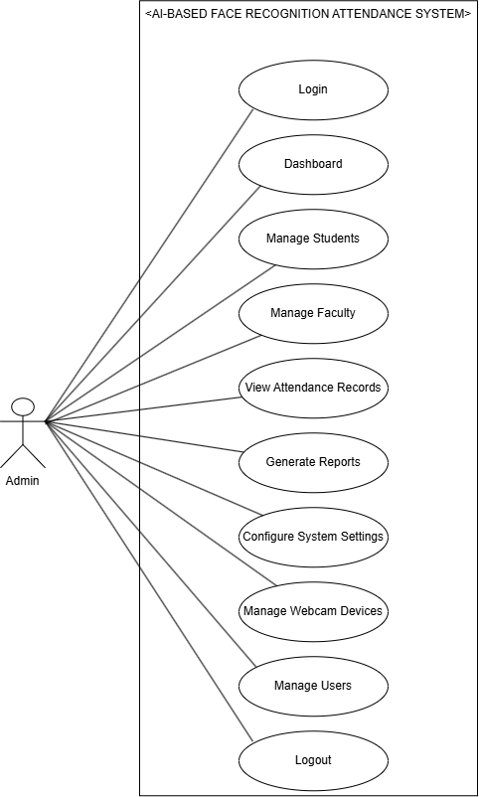
4.2 Use Case Diagram – Faculty
The Faculty is responsible for conducting and managing student attendance. The main use cases of the Faculty are:
- Login to the system
- Start an attendance session
- Access camera input
- Initiate face recognition
- Monitor attendance marking
- View student attendance records
- Search and filter attendance information
- View attendance reports
- Close attendance sessions
- Logout from the system
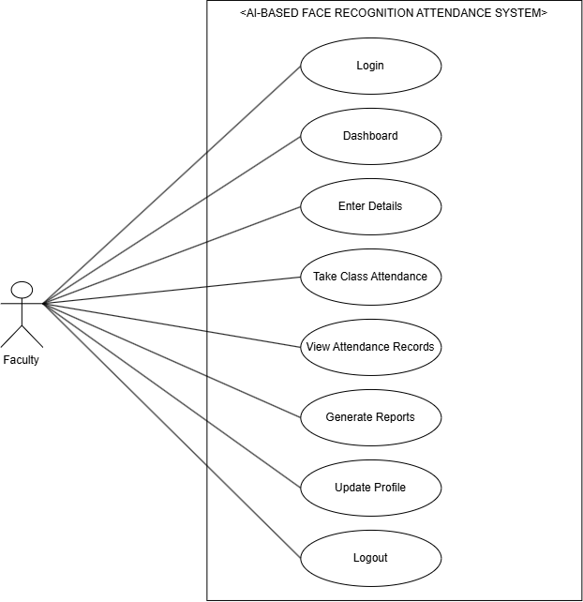
4.3 Use Case Diagram – Student
The Student is registered in the system and participates in the automated attendance process. The main use cases of the Student are:
- Register personal information
- Provide facial data for face registration
- Participate in an attendance session
- Get identified through face recognition
- Have attendance marked automatically
- View personal attendance records
- View attendance history
- Logout from the system
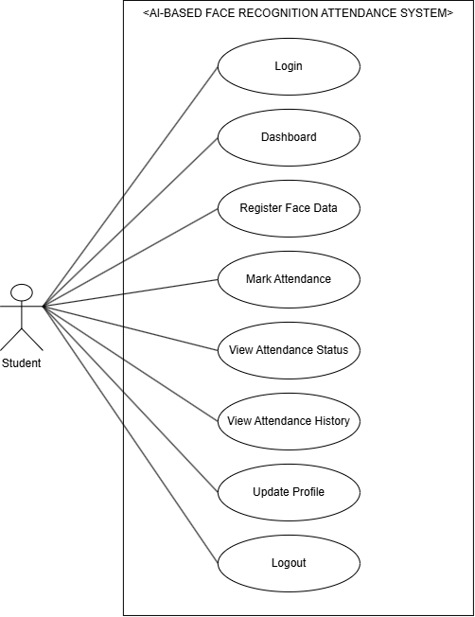

4.2 Sequence Diagrams
Sequence Diagrams show the step-by-step interaction between different actors, system components, and the database over time. They describe how requests and information flow through the AttendAI – AI-Based Smart Attendance Management System using Face Recognition for specific operations.
The main actors involved in the system are Admin, Faculty, and Student. The following sequence diagrams represent the major workflows of the system.

Sequence Diagram 1: Admin Managing Student Registration
This sequence diagram shows how the Admin registers and manages student information in the system. The Admin logs into the system, enters the student's details, captures or uploads the student's facial data, and submits the information. The system processes the facial data and stores the student information and face data in the database.

Sequence Diagram 2: Faculty Conducting Attendance Session
This sequence diagram shows how the Faculty starts an attendance session and uses the face recognition system to mark student attendance. The Faculty logs into the system and starts an attendance session. The camera captures the student's face, and the AI face recognition module processes and compares it with the registered facial data. After successful verification, the attendance record is stored in the database.
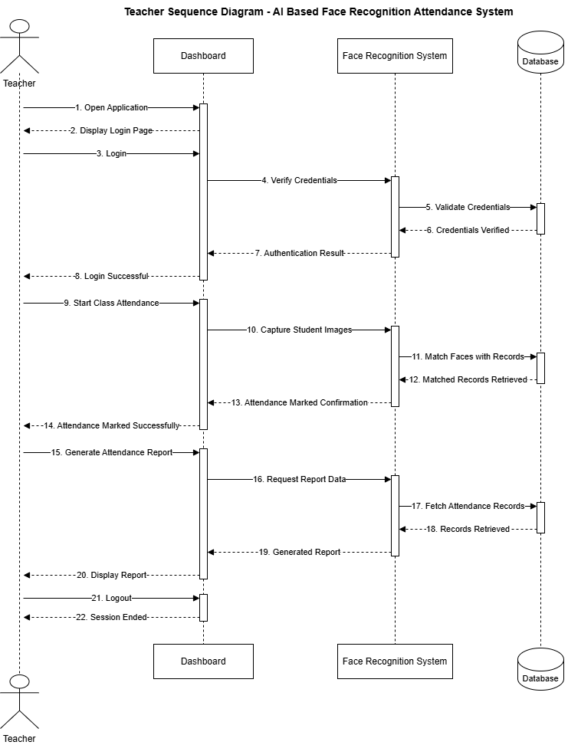
Sequence Diagram 3: Student Face Recognition and Attendance Marking
This sequence diagram represents the interaction when a Student participates in an active attendance session. The student's face is captured through the camera and sent to the face recognition module. The system detects and compares the face with the registered facial information. After successful identity verification, the system automatically marks the student's attendance and updates the attendance records.
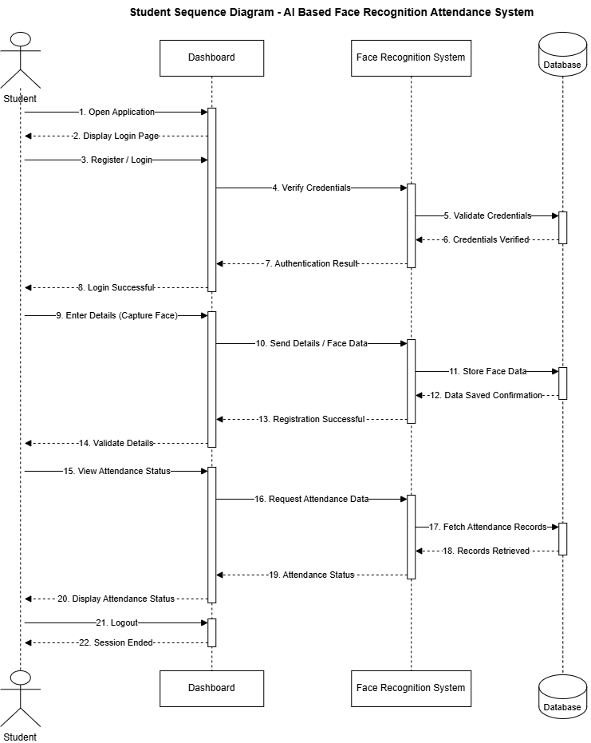

4.3 Activity Diagrams
Activity Diagrams represent the flow of activities and decision-making processes for major operations in the AttendAI – AI-Based Smart Attendance Management System using Face Recognition. These diagrams show how different activities are performed step by step by the main actors of the system, namely Admin, Faculty, and Student.
Activity Diagram 1: Admin Login and Student Registration
This activity diagram shows the process followed by the Admin to log into the system and register a student. The process starts when the Admin enters login credentials. After successful authentication, the Admin accesses the student management section, enters the student's personal details, and captures or uploads facial data. The system processes the information and stores the student details and facial data in the database.
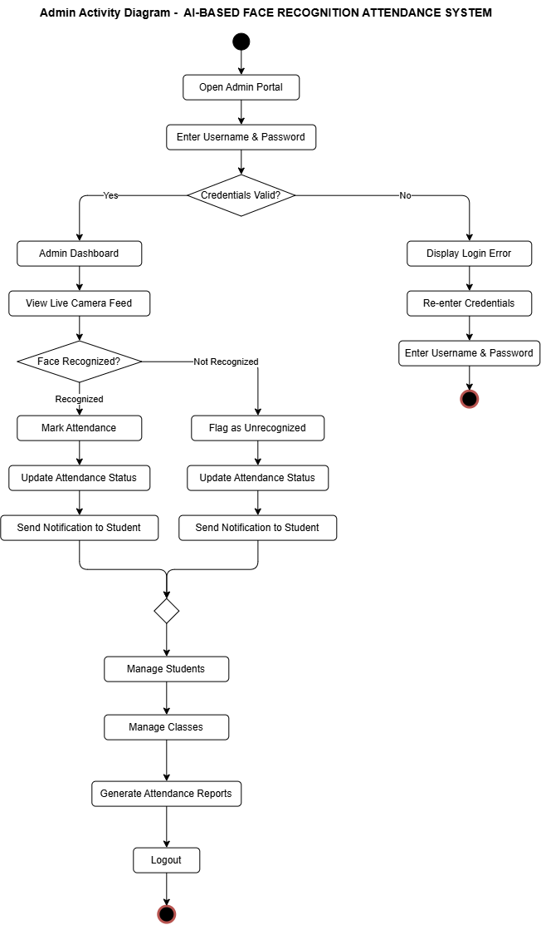Activity Diagram 2: Faculty Conducting Attendance Session
This activity diagram represents the process followed by the Faculty to conduct an attendance session. The Faculty logs into the system and starts an attendance session. The system activates the camera and captures student faces. The face recognition module detects and verifies the faces against the registered facial data. If verification is successful, the attendance is marked automatically and stored in the database. The process continues until the Faculty ends the attendance session.
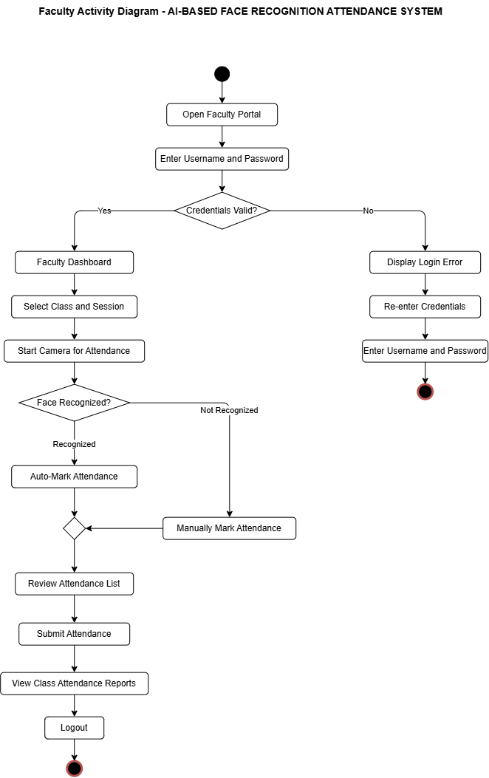Activity Diagram 3: Student Face Recognition and Attendance Marking
This activity diagram represents the process through which a Student's attendance is recorded. The Student appears in front of the camera during an active attendance session. The system captures and detects the student's face and sends it to the AI-based face recognition module. The system compares the detected face with registered facial data. If the identity is successfully verified, the student's attendance is marked and the attendance record is updated in the database. If recognition fails, the system requests another face capture or verification attempt.
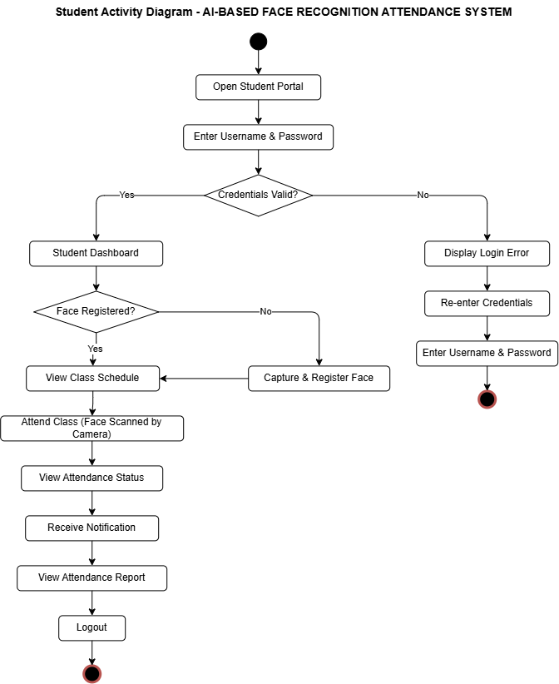

4.4 Class Diagram
The Class Diagram represents the main classes, attributes, methods, and relationships used in the proposed AttendAI – AI-Based Smart Attendance Management System using Face Recognition. It provides a static view of the system architecture and shows how different components of the system are connected with each other.
The major classes of the system include Admin, Faculty, Student, Department, AttendanceSession, AttendanceRecord, FaceRecognition, FaceData, and Report. The Admin class manages the overall system, including student information, faculty details, departments, and attendance records. The Faculty class is responsible for conducting and managing attendance sessions, while the Student class stores the personal and academic information of registered students.
The FaceData and FaceRecognition classes manage facial information and perform face detection, feature extraction, identity comparison, and verification. The AttendanceSession class represents an active attendance session created by the Faculty, whereas the AttendanceRecord class stores the attendance status, date, time, and other related information for each student.
The Department class maintains department-related information and establishes relationships between students and faculty members. The Report class is responsible for generating attendance reports and exporting attendance data. These classes interact with the database and other system modules to ensure efficient management of attendance information.
The relationships between the classes can include associations such as one Department having multiple Students and Faculty members, one Faculty managing multiple Attendance Sessions, and one Attendance Session containing multiple Attendance Records. Similarly, each Student can have multiple Attendance Records and associated facial data for identification.
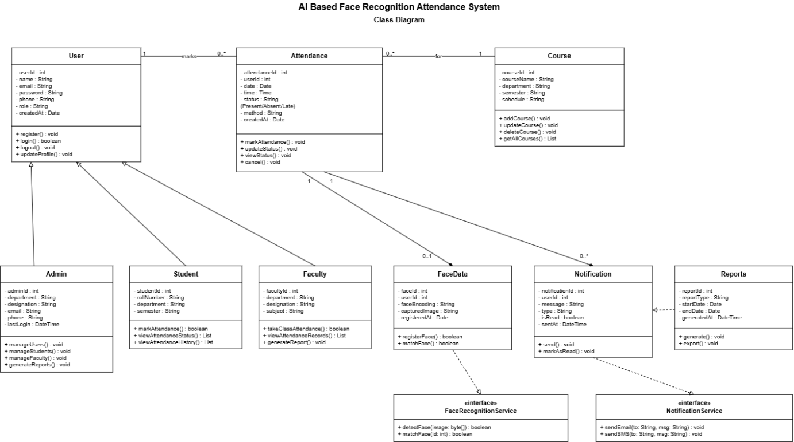
4.5 Entity Relationship Diagram
The Entity Relationship (ER) Diagram represents the database structure of the proposed AttendAI – AI-Based Smart Attendance Management System using Face Recognition. It shows the main entities of the system, their important attributes, and the relationships between them. The ER Diagram provides a clear understanding of how student information, faculty details, facial data, attendance sessions, and attendance records are stored and connected in the database.
The major entities of the system include Admin, Faculty, Student, Department, Face Data, Attendance Session, and Attendance Record. The Admin manages the overall system and maintains important records. The Department entity stores department-related information and can be associated with multiple Faculty members and Students. The Faculty entity stores faculty information and is responsible for conducting attendance sessions.
The Student entity stores the personal and academic details of registered students. Each Student is associated with facial information stored in the Face Data entity, which is used by the AI-based face recognition system for identity verification. The Faculty creates and manages an Attendance Session, and each attendance session can contain attendance records for multiple students.
The Attendance Record entity stores the attendance details of each student, including information such as the attendance date, time, status, and session details. A Student can have multiple attendance records over different attendance sessions, while one attendance session can contain records for multiple students. These relationships ensure that the database remains organized and that attendance information can be efficiently stored, retrieved, and managed.
The main relationships represented in the ER Diagram are as follows:
- One Department can have multiple Faculty members.
- One Department can have multiple Students.
- One Faculty can manage multiple Attendance Sessions.
- One Student can have associated Face Data.
- One Attendance Session can contain multiple Attendance Records.
- One Student can have multiple Attendance Records.
- Each Attendance Record is linked to a specific Student and Attendance Session.
____________________ [ Insert Entity Relationship Diagram here ] ____________________
6. DATA DICTIONARY
The Data Dictionary provides detailed information about the important tables used in the database of the proposed AttendAI – AI-Based Smart Attendance Management System using Face Recognition. It describes the main database entities, their attributes, data types, and the purpose of the information stored in each table.
The database is designed to manage information related to Students, Faculty, Admin, Attendance, Face Data, Notifications, and Courses. These tables work together to store academic information, user details, facial recognition data, attendance records, notifications, and course-related information efficiently.
6.1 Student
The Student table stores the personal and academic details of students registered in the system.
6.2 Faculty
The Faculty table stores information about faculty members responsible for managing and conducting attendance sessions.
6.3 Admin
The Admin table stores information about the system administrator who manages the overall AttendAI system.
6.4 Attendance
The Attendance table stores the attendance records generated after successful face recognition and verification.
6.5 FaceData
The FaceData table stores facial information required for AI-based face recognition and student identity verification.
6.6 Notification
The Notification table stores system-generated notifications and important messages for Admin, Faculty, and Students.
6.7 Course
The Course table stores information about courses associated with students and faculty members.
These tables collectively form the database foundation of the AttendAI system. The relationships between the Student, Faculty, Admin, Attendance, FaceData, Notification, and Course tables allow the system to efficiently manage user information, facial recognition data, automated attendance records, notifications, and academic details.

